

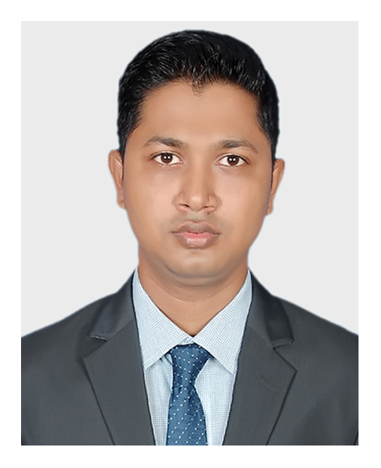

**Career Objectives**

To work in an environment where there is an opportunity of self-assessment and self-improvement in both individual and group-based work that will ultimately lead to further development of the common people and Looking for a challenging opportunity to sharpen my skills and knowledge in a fast-paced organization and to grow as a lead!

**Training**

1. IsDB IT Scholarship Project

* Enterprise System Analysis & Design – JEE

**Skills**

Languages : Java, SQL, JavaScript

Frameworks : Spring, JSF, Angular, Bootstrap

Mobile OS : Android

Libraries : JQuery, ReactJs

Database : MySQL, Oracle

Web Design : Html, CSS,

Concepts : UML, Digital Marketing

Other : Git, Firebase, NodeJs, SQLite3

**Projects**

1. Hospital Management & Information System

* Technologies Used: Java, Spring, Tomcat, Hibernate, MySQL, Jquery, Bootstrap
* [github.com/themizan404/SpringProject](https://github.com/mizan404/SpringProject)

2. E-Voting Management System

* Technologies Used: Java, Swing, MySQL
* [github.com/themizan404/All-Swing/tree/master/vote_management](https://github.com/mizan404/All-Swing/tree/master/vote_management)

**References**

1. Moshaidul Islam

IsDB-BISEW, Consultant of IsDB-BISEW

01711071219

[moshaidul@gmail.com](mailto:moshaidul@gmail.com)

2. Muhammad Maruf Hasan

IsDB-BISEW, Instructor of IsDB-BISEW

01825970006

[maruf.tcl@gmail.com](mailto:maruf.tcl@gmail.com)

**Personal Info**

Father’s Name : Md. Babar Ali

Mother’s Name : Sultana Parvin

Date of Birth : 16th Nov, 1994

Gender : Male

Religion : Islam

Nationality : Bangladeshi

Marital Status : Single

NID : 5550086796

**Permanent Address**

Pachani, Alaipur (9240), Rupsha, Khulna.

**Education**

MSS in Economics (Appeared)

University of Dhaka

BSS in Economics (2016)

CGPA: 2.99

University of Dhaka

HSC in Humanities (2011)

GPA: 4.60

Dhaka Board

SSC in Humanities (2009)

GPA: 4.06

Dhaka Board

**Language Proficiency**

Bengali: Native speaker

English: Professional working efficiency

**Follow Me**

* [github.com/themizan404](https://github.com/themizan404)
* [facebook.com/themizan404](https://www.facebook.com/themizan404/)
* [linkedin.com/in/themizan404](https://www.linkedin.com/in/themizan404/)

**Md. Mizanur Rahman**

**Mailing Address**

Address: 257-258, Rose Elegance,

Ibrahimpur Primary School Road, Ibrahimpur, Kafrul, Dhaka-1206.

Phone: 01680225343

Email: [themizan404@gmail.com](mailto:themizan404@gmail.com)

**Signature**